

## **Centurion University of Technology and Management**

**Minor Project**

**(CUTM 1906)**

**Project Report**

**Spectacles Detection Using Machine Learning**

**</>**

**Rakesh Sharma - 190301120079**

**Ankita Panigrahi - 190301250002**

**Computer Science and Engineering**

**Centurion University of Technology and Management, BBSR**

**Introduction**

The project is on Spectacles detection: - a real-time system to detect whether the person on the webcam is wearing a spectacle or not. Eye detection plays an important role in many Intelligent Human Computer Interaction (IHCI) applications such as eye tracking, eye gaze tracking, drowsiness monitoring etc. However, the presence of spectacles makes the eye detection task difficult because of the glint produced by the lens. Earlier approaches on detection of eyes occluded with spectacles have been reported in literature, however with limited accuracies. This paper proposes a real-time algorithm for detection of spectacles leading to the detection of eyes. So, I decided to create an application using Machine Learning that utilizes a camera to detect if a person is wearing a spectacle or not.

***Machine Learning***

Machine learning (ML)is the study of computer algorithms that improve automatically through experience. Itis seen as a subset of artificial intelligence. Machine learning algorithms build a mathematical model based on sample data, known as "training data", in order to make predictions or decisions without being explicitly programmed to do so. Machine learning algorithms are used in a wide variety of applications, such as email filtering and computer vision, where it is difficult or infeasible to develop conventional algorithms to perform the needed tasks. Machine learning is closely related to computational statistics, which focuses on making predictions using computers. The study of mathematical optimization delivers methods, theory and application domains to the field of machine learning. Data mining is a related field of study, focusing on exploratory data analysis through unsupervised learning. In its application across business problems, machine learning is also referred to as predictive analytics. Machine learning approaches are traditionally divided into three broad categories, depending on the nature of the "signal" or "feedback" available to the learning system

* Supervised learning: The computer is presented with example inputs and their desired outputs, given by a "teacher", and the goal is to learn a general rule that maps inputs to outputs.
* Unsupervised learning: No labels are given to the learning algorithm, leaving it on its own to find structure in its input. Unsupervised learning can be a goal in itself (discovering hidden patterns in data) or a means towards an end (feature learning).

**Machine Learning Model**

The Machine learning algorithm which are used in this project are as follows: -

1. **Support Vector Machine**

Support Vector Machine or SVM is one of the most popular Supervised Learning algorithms, which is used for Classification as well as Regression problems. However, primarily, it is used for Classification problems in Machine Learning. The goal of the SVM algorithm is to create the best line or decision boundary that can segregate n-dimensional space into classes so that we can easily put the new data point in the correct category in the future. This best decision boundary is called a hyperplane. SVM chooses the extreme points/vectors that help in creating the hyperplane. These extreme cases are called as support vectors, and hence the algorithm is termed as Support Vector Machine. Consider the below diagram in which there are two different categories that are classified using a decision boundary or hyperplane

1. **Viola–Jones Face Detection Algorithm**

The Viola–Jones object detection framework is an object detection framework which was proposed in 2001 by Paul Viola and Michael Jones. Although it can be trained to detect a variety of object classes, it was motivated primarily by the problem of face detection. The characteristics of Viola–Jones algorithm which make it a good detection algorithm are:

Robust – very high detection rate (true-positive rate) & very low false-positive rate always.

Real time – For practical applications at least 2 frames per second must be processed.

Face detection only (not recognition) - The goal is to distinguish faces from non-faces (detection is the first step in the recognition process).

The algorithm has four stages:

* Haar Feature Selection
* Creating an Integral Image
* Adaboost Training
* Cascading Classifiers

The features sought by the detection framework universally involve the sums of image pixels within rectangular areas. As such, they bear some resemblance to Haar basis functions, which have been used previously in the realm of image-based object detection. However, since the features used by Viola and Jones all rely on more than one rectangular area, they are generally more complex. The figure on the right illustrates the four different types of features used in the framework. The value of any given feature is the sum of the pixels within clear rectangles subtracted from the sum of the pixels within shaded rectangles. Rectangular features of this sort are primitive when compared to alternatives such as steerable filters. Although they are sensitive to vertical and horizontal features, their feedback is considerably coarser.

**SOFTWARE REQUIREMENTS**

* Python 3.9
* Code Editor
* Jupyter Notebook

**LIBRARY REQUIREMENTS**

* OpenCV: - OpenCV (Open Source Computer Vision Library) is an open source computer vision and machine learning software library. OpenCV was built to provide a common infrastructure for computer vision. The library has more than 2500 optimized algorithms, which includes a comprehensive set of both classic and state-of-the-art computer vision and machine learning algorithms. These algorithms can be used to detect and recognize faces, identify objects, classify human actions in videos, track camera movements, track moving objects etc.
* Scikit-learn: - Scikit-learn (Sklearn) is the most useful and robust library for machine learning in Python. It provides a selection of efficient tools for machine learning and statistical modeling including classification, regression, clustering and dimensionality reduction via a consistent interface in Python.
* NumPy :- stands for Numerical Python, is a library consisting of multidimensional array objects and a collection of routines for processing those arrays.
* Matplotlib:- Matplotlib is a comprehensive library for creating static, animated, and interactive visualizations.

**Data set Collection**

* Data set is collected using a web camera while doing the project.
* Data set contains 400 images.

200 images of people wearing Specs

200 images of people not wearing Specs

**Implementation**

1. Data set Processing

* Load images using python
* Convert images into Array
* After loading images, we can perform any algorithm on array we have

1. Extracting Face from Images

* Haar Feature selection
* Creating an Integral Image
* AdaBoost Training
* Cascading Classification
* To implement this steps we will use cascading .xml file i.e downloaded from GitHub

1. Training and Testing of Model Using SVM

* Split data into attributes and labels.
* Divide the data into training and testing sets.
* Train the SVM algorithm
* Start Specs Detection

***Source Code***

**Data Collection**

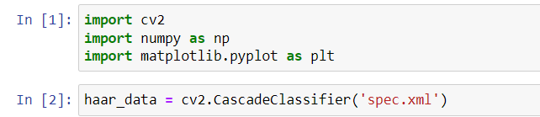

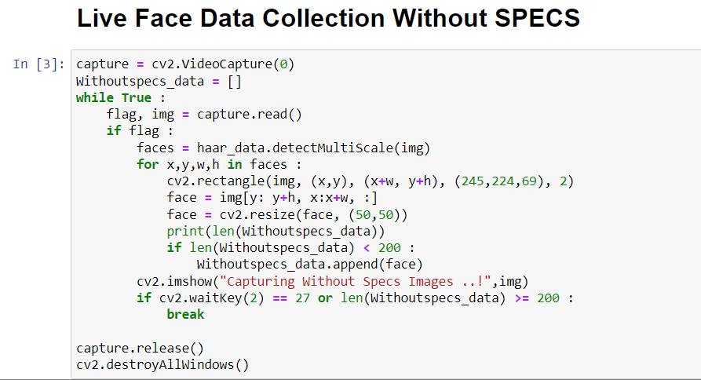

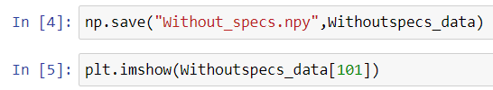

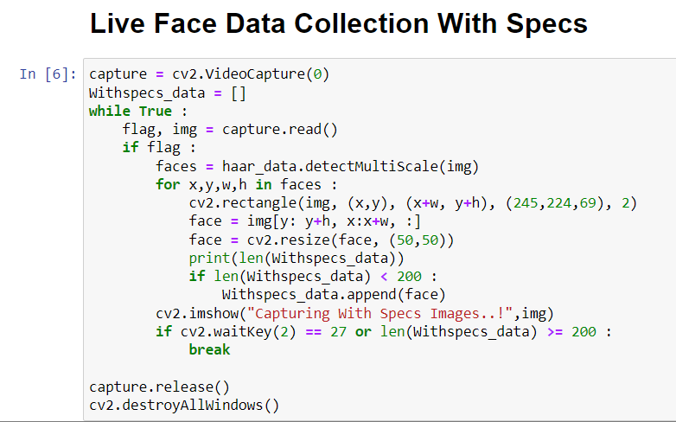

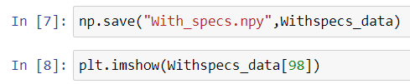

**Model Training and Testing**

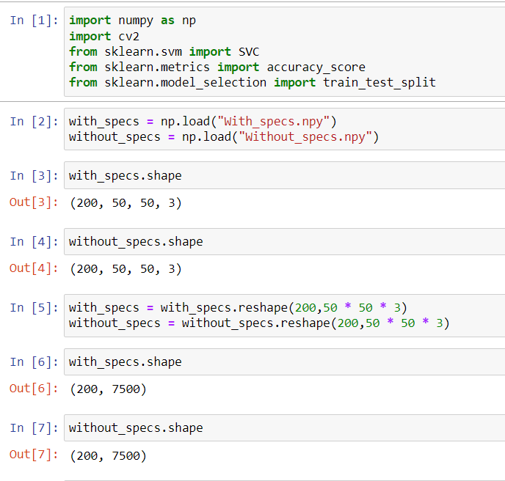

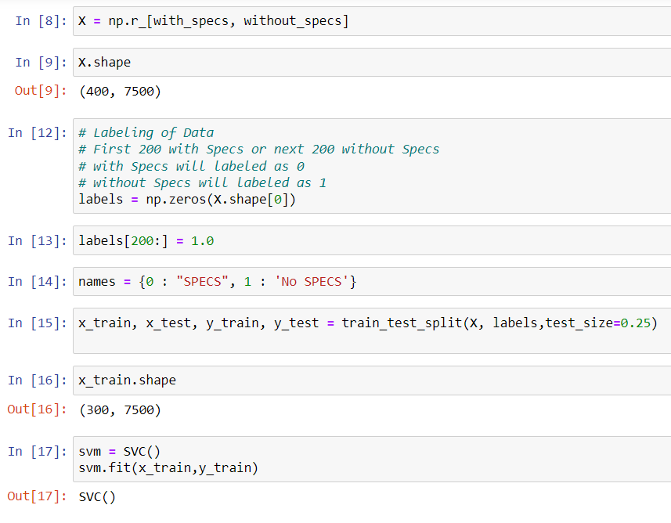

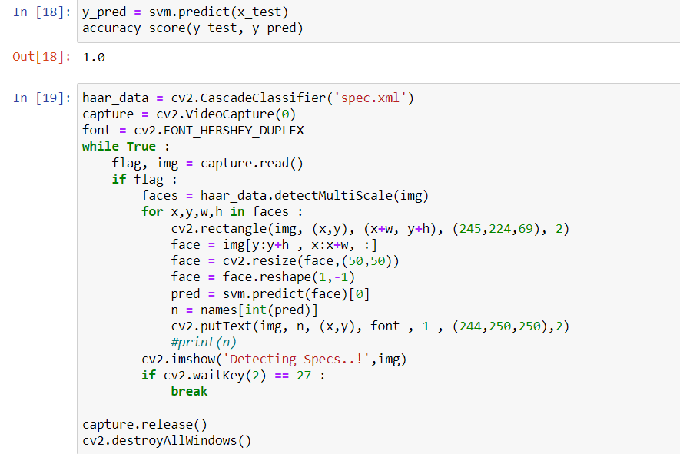

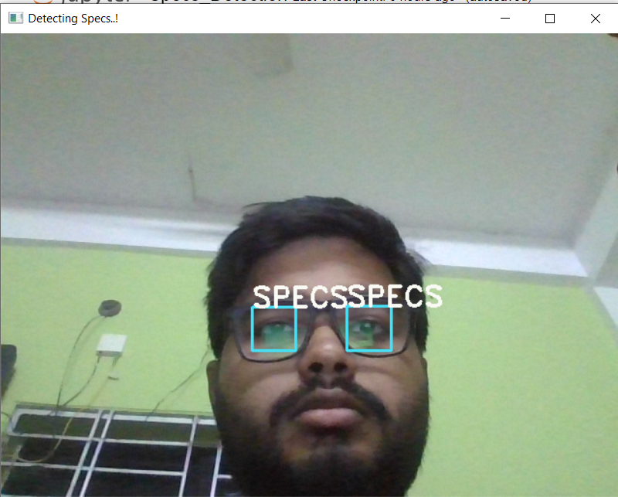**Output**

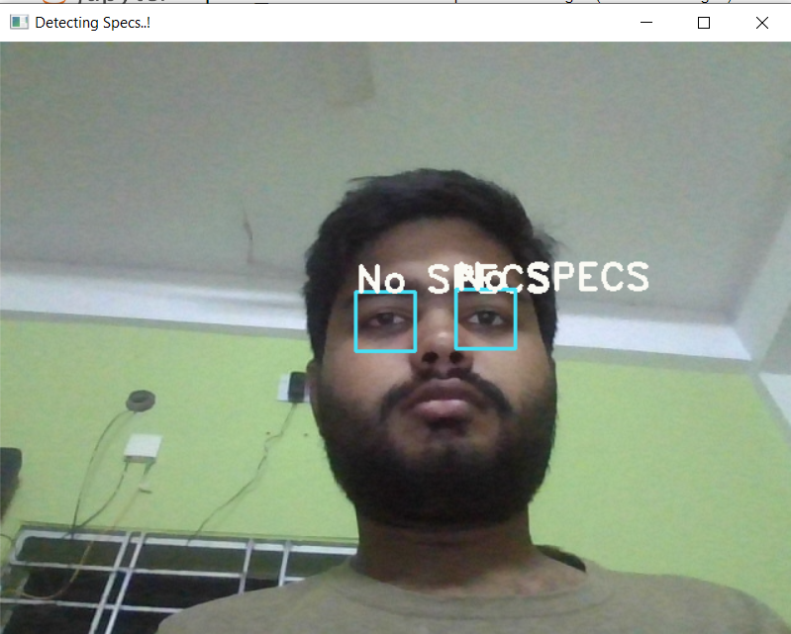

**Conclusion**

This project presents a real-time algorithm for detection of spectacles leading to the detection of eyes. In this paper, the

face has been detected using Haar-like features and an ROI

has been selected from the detected face region. The problems in the algorithms have been discussed and fine tuning of the algorithm has been done to improve the accuracy. However, there is further scope of research in the improvement of accuracy of spectacle detection. Removal of glint caused by the glasses is another potential future scope of this research.